YouTube-Videos von UbiBot

UbiBot YouTube – Kanal:

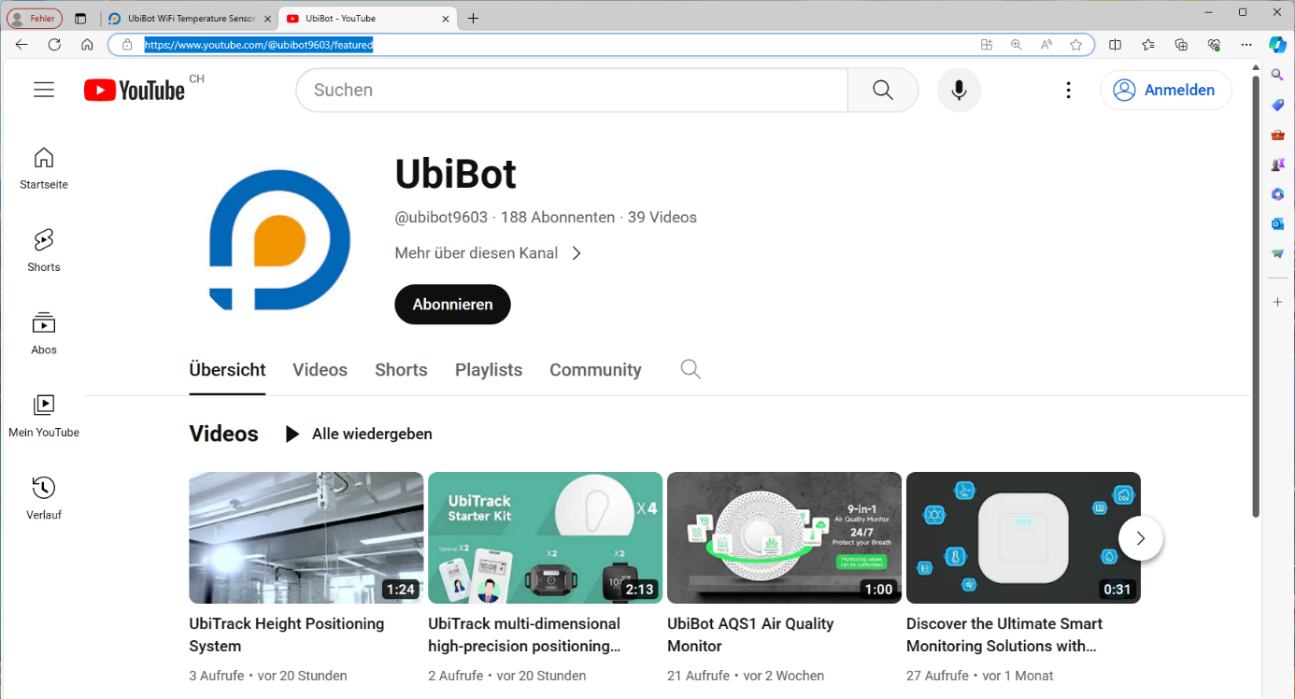

UbiBot - YouTube
https://www.youtube.com/@ubibot9603/featured

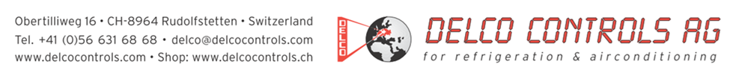

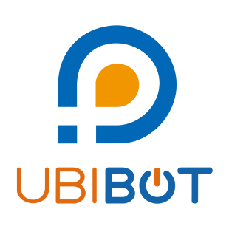
Allgemein über UbiBot:

Discover the Ultimate Smart Monitoring Solutions with UbiBot Products (youtube.com)
https://www.youtube.com/watch?v=jqY6UmUTSlk

UbiBot Big Data IoT system theory introduction (youtube.com)
https://www.youtube.com/watch?v=1bADI2hC04w

UbiBot Big Data IoT system theory introduction - YouTube
https://www.youtube.com/watch?v=1bADI2hC04w&t=6s

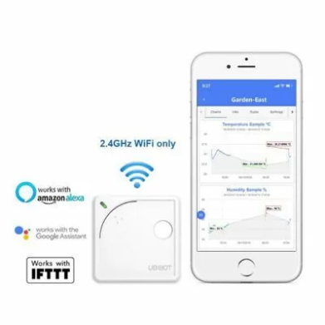
WS1: WiFi Datenlogger

UbiBot WS1 All in One Wireless Temperature Humidity Monitor. (youtube.com)
https://www.youtube.com/watch?v=DSQbfwiXwCw

UbiBot® Wireless Environment Sensing Device WiFi Connection Setup Guidance (youtube.com)
https://www.youtube.com/watch?v=fTmc7euwAu4

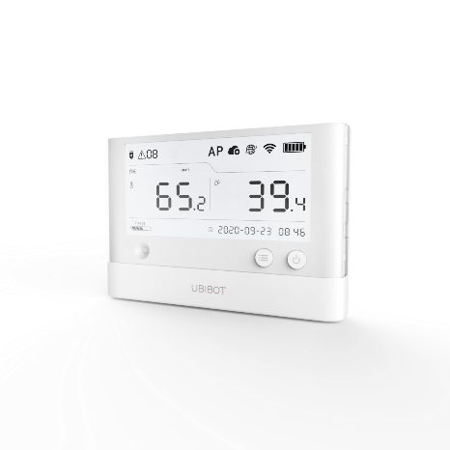
WS1 Pro: WiFi Datenlogger

UbiBot WS1 Pro Intelligent All in One Wireless Temperature Humidity Monitor (youtube.com)
https://www.youtube.com/watch?v=PwINpBLirvQ

Sim Card configuration for UbiBot WS1 PRO SIM (youtube.com)
https://www.youtube.com/watch?v=SeEDJSYzpjo

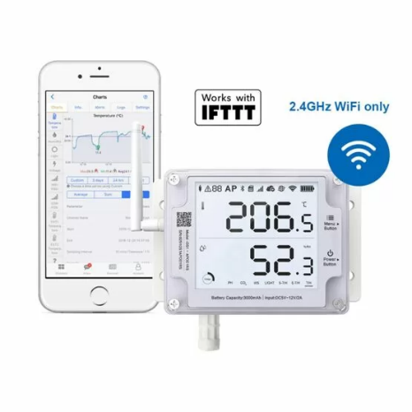
GS1: WiFi Datenlogger

UbiBot GS1 Industrial-Grade Wireless Environmental Monitor (youtube.com)
https://www.youtube.com/watch?v=cHdHMFQTDPo

Sim Card Configuration for UbiBot GS1-AL4G1RS (youtube.com)
https://www.youtube.com/watch?v=tgvgMq7XZag

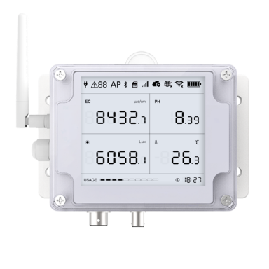
GS2: WiFi Datenlogger

UbiBot GS2-EL EC & pH value remote monitoring (youtube.com)
https://www.youtube.com/watch?v=sEFODWHi6kU

UbiBot GS2 PH probe calibration for use to test alkaline liquid (youtube.com)
https://www.youtube.com/watch?v=eVNF-nos3VE

UbiBot GS2 PH probe calibration for use to test acid liquid (youtube.com)
https://www.youtube.com/watch?v=QWUcmQnee7w

UbiBot GS2 EC probe calibration introduction (youtube.com)
https://www.youtube.com/watch?v=ilG5IbfXFIQ

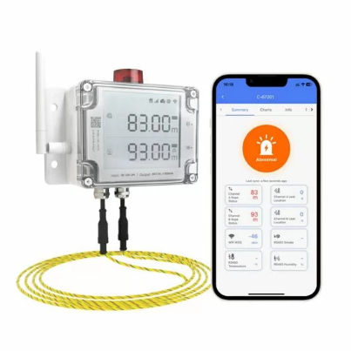
LD1: WiFi Lecksucher

UbiBot Smart Water Leak Detector LD1 (youtube.com)
https://www.youtube.com/watch?v=uJbKAbbsugg

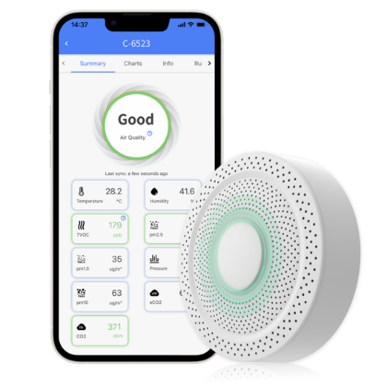
AQS1:
WiFi Luftqualitätssensor

UbiBot AQS1 Air Quality Monitor (youtube.com)
https://www.youtube.com/watch?v=7rzAMxI7CU4

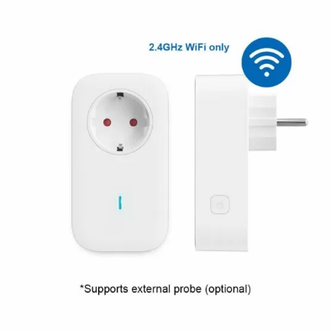
SP1:
WiFi Smart Plug

UbiBot Cloud-supported IoT WiFi automatic/remote control Smart Plug SP1 (youtube.com)
https://www.youtube.com/watch?v=nMiLRpTLJjU

Sim Card configuration for UbiBot SP1 smart plug (youtube.com)
https://www.youtube.com/watch?v=1n17TTo1dBo

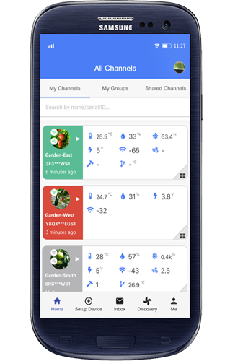
APP:

WiFi Configuration Guide for UbiBot devices (youtube.com)
https://www.youtube.com/watch?v=iPzi7Z_qxS8

How to set alerts on the UbiBot app (youtube.com)
https://www.youtube.com/watch?v=WVlMsBVx67A

UbiBot® Device WiFi Connection Setup Guidance (youtube.com)
https://www.youtube.com/watch?v=GfSEHmZfwZ0

Instructions on how to set alert rules for UbiBot device (youtube.com)
https://www.youtube.com/watch?v=Ra9nMVm0oPc

Introduction of the features of the UbiBot App (youtube.com)
https://www.youtube.com/watch?v=AV7-WBJW_Y0

UbiBot mobile widget is now live！ (youtube.com)
https://www.youtube.com/watch?v=00SDtAvGnvw

